**NAME OF THE QUESTION:**

**Exercise 1**: Implementing the Singleton Pattern

**CODE:**

**Logger.java**

public class Logger {

private static Logger instance;

private Logger() {

System.out.println("Logger instance created.");

}

public static Logger getInstance() {

if (instance == null) {

instance = new Logger();

}

return instance;

}

public void log(String message) {

System.out.println("Log: " + message);

}

}

**Main.java**

public class Main {

public static void main(String[] args) {

Logger logger1 = Logger.getInstance();

logger1.log("First message");

Logger logger2 = Logger.getInstance();

logger2.log("Second message");

if (logger1 == logger2) {

System.out.println("Both logger instances are the same (Singleton works).");

} else {

System.out.println("Logger instances are different (Singleton failed).");

}

}

}

**OUTPUT:**

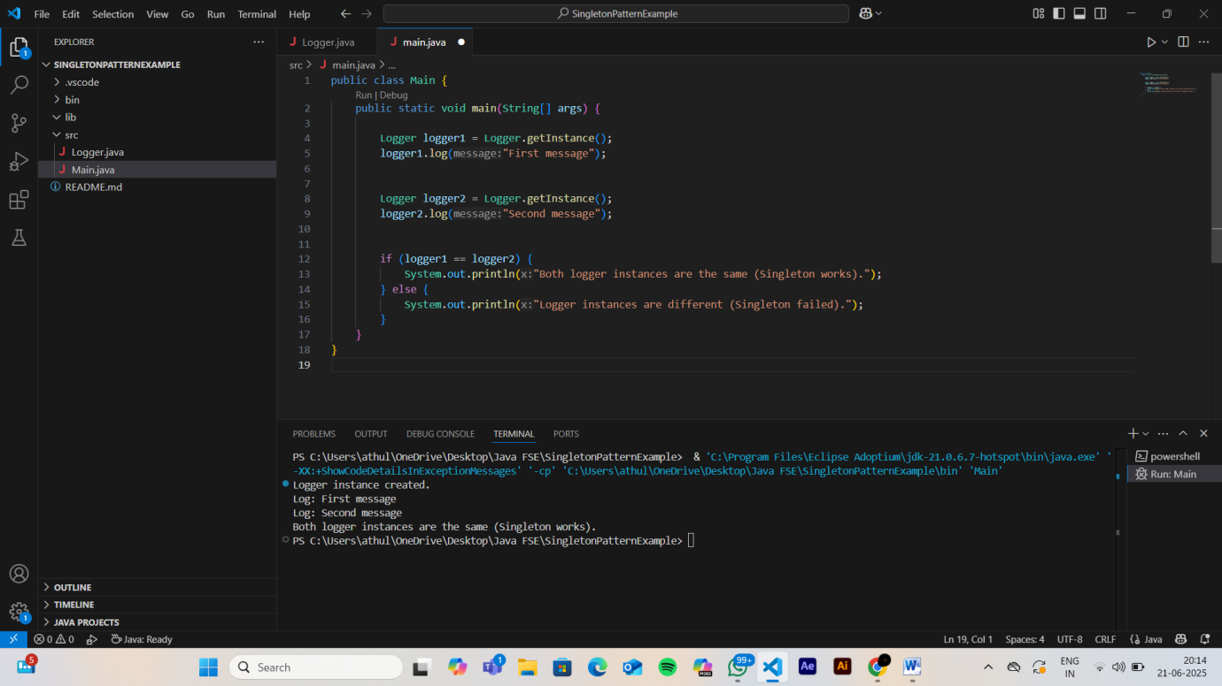

**NAME OF THE QUESTION:**

**Exercise 2:** Implementing the Factory Method Pattern

**CODE:**

**Document.java**

public interface Document {

void open();

}

**WordDocument.java**

public class WordDocument implements Document {

@Override

public void open() {

System.out.println("Opening Word document.");

}

}

**PdfDocument.java**

public class PdfDocument implements Document {

@Override

public void open() {

System.out.println("Opening PDF document.");

}

}

**ExcelDocument.java**

public class ExcelDocument implements Document {

@Override

public void open() {

System.out.println("Opening Excel document.");

}

}

**DocumentFactory.java**

public abstract class DocumentFactory {

public abstract Document createDocument();

}

**WordDocumentFactory.java**

public class WordDocumentFactory extends DocumentFactory {

@Override

public Document createDocument() {

return new WordDocument();

}

}

**PdfDocumentFactory.java**

public class PdfDocumentFactory extends DocumentFactory {

@Override

public Document createDocument() {

return new PdfDocument();

}

}

**ExcelDocumentFactory.java**

public class ExcelDocumentFactory extends DocumentFactory {

@Override

public Document createDocument() {

return new ExcelDocument();

}

}

**Main.java**

public class Main {

public static void main(String[] args) {

DocumentFactory wordFactory = new WordDocumentFactory();

Document wordDoc = wordFactory.createDocument();

wordDoc.open();

DocumentFactory pdfFactory = new PdfDocumentFactory();

Document pdfDoc = pdfFactory.createDocument();

pdfDoc.open();

DocumentFactory excelFactory = new ExcelDocumentFactory();

Document excelDoc = excelFactory.createDocument();

excelDoc.open();

}

}

**OUTPUT:**

